**EXERCISE 4**-**FUNCTIONS**

**SCENARIO 1: CalculateAge function**

**CREATING PROCEDURE:**

CREATE OR REPLACE FUNCTION CalculateAge (

    p_dob DATE

) RETURN NUMBER

IS

    v_age NUMBER;

BEGIN

    v_age := FLOOR(MONTHS_BETWEEN(SYSDATE, p_dob) / 12);

    RETURN v_age;

END;

/

SELECT CalculateAge(TO_DATE('1985-05-15','YYYY-MM-DD')) AS Age FROM dual;

**OUTPUT:**

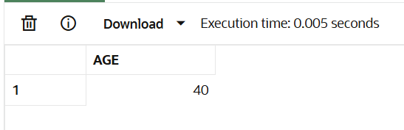

**SCENARIO 2:** **CalculateMonthlyInstallment function**

CREATE OR REPLACE FUNCTION CalculateMonthlyInstallment (

    p_loan_amount NUMBER,

    p_annual_interest_rate NUMBER,

    p_years NUMBER

) RETURN NUMBER

IS

    v_monthly_rate NUMBER;

    v_n NUMBER;

    v_emi NUMBER;

BEGIN

    v_monthly_rate := p_annual_interest_rate / (12*100);

    v_n := p_years * 12;

    v_emi := p_loan_amount * v_monthly_rate * POWER(1+v_monthly_rate, v_n) /

            (POWER(1+v_monthly_rate, v_n) - 1);

    RETURN ROUND(v_emi,2);

END;

/

SELECT CalculateMonthlyInstallment(100000, 12, 5) AS EMI FROM dual;

**OUTPUT:**

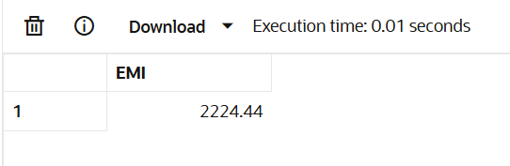

**SCENARIO 3:** **HasSufficientBalance function**

CREATE OR REPLACE FUNCTION HasSufficientBalance (

    p_account_id NUMBER,

    p_amount NUMBER

) RETURN BOOLEAN

IS

    v_balance NUMBER;

BEGIN

    SELECT Balance INTO v_balance

    FROM Accounts

    WHERE AccountID = p_account_id;

    IF v_balance >= p_amount THEN

        RETURN TRUE;

    ELSE

        RETURN FALSE;

    END IF;

EXCEPTION

    WHEN NO_DATA_FOUND THEN

        RETURN FALSE;

END;

/

SET SERVEROUTPUT ON;

DECLARE

    v_result BOOLEAN;

BEGIN

    v_result := HasSufficientBalance(101, 1000);  -- check for 1000

    IF v_result THEN

        DBMS_OUTPUT.PUT_LINE('Sufficient balance.');

    ELSE

        DBMS_OUTPUT.PUT_LINE('Insufficient balance.');

    END IF;

END;

/

**OUTPUT:**

**:**